Secondary Analysis

**Glide**

**Website:**<https://www.glideapps.com/>

**Cost:** Varies, Free and/or $20 Month

**Pros:**

* Easily transformers Google Sheets into a mobile friendly app
* Allows users to view Google Spreadsheet in a highly visual way
* Extensive online knowledgebase

**Cons:**

* May be cumbersome to set-up
* Mobile only (no desktop app/website), changes to data occurs every three minutes, although sometimes these changes will happen immediately[1]
* Spreadsheet may have to be re-designed with Glide in mind

**Description:** Glide is a new startup that helps users create visually stunning mobile web-apps by using Google Sheets as the information back-end. Users can easily add, edit, or delete Google Sheets data right from Glide’s webapp. Specific users can even be given specific data entry rights to add, delete, or modify data. Glide can even integrate with custom domains and e-commerce platforms like Stripe. Notifications can even be set-p using a service like Zapier.[2]

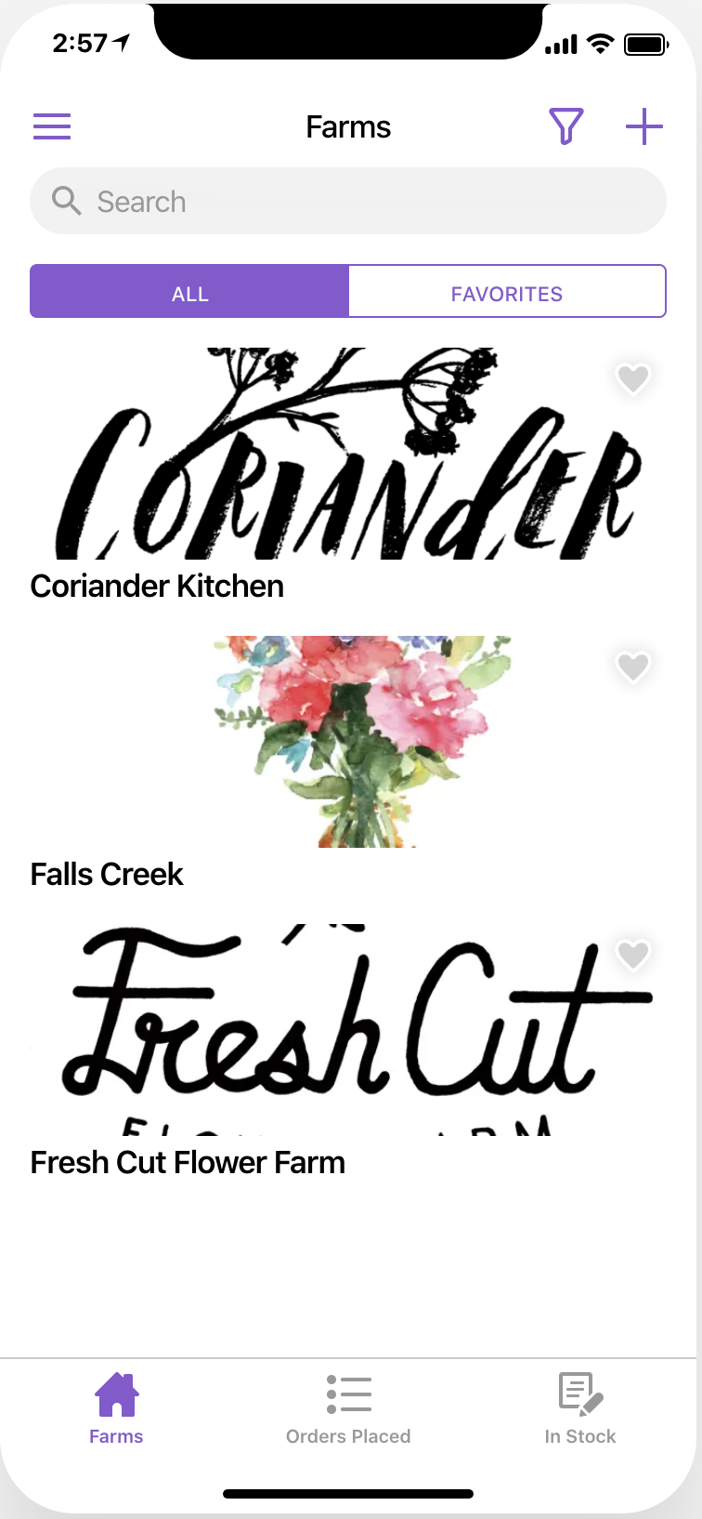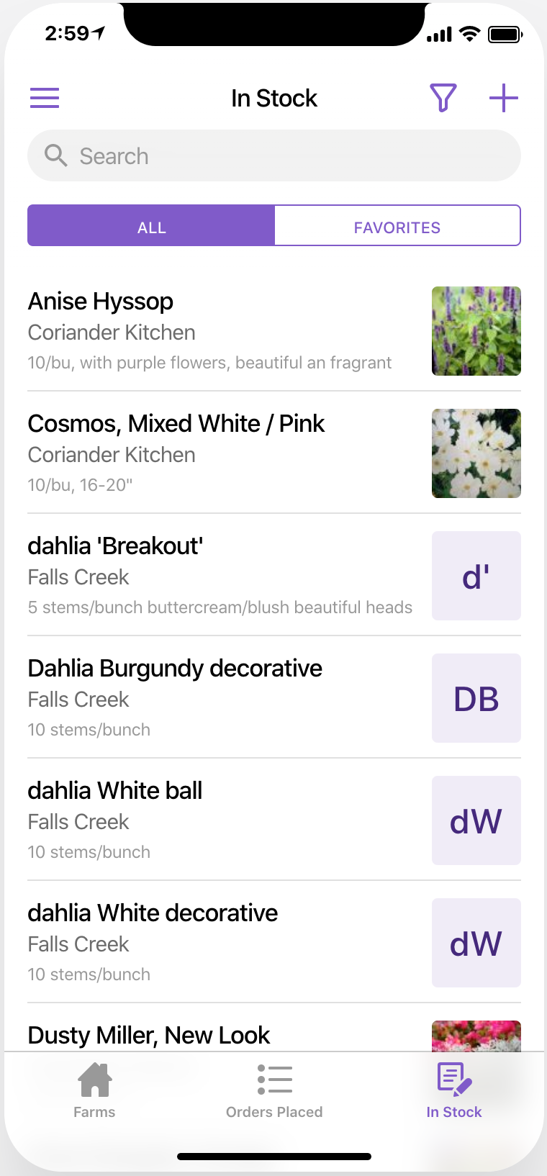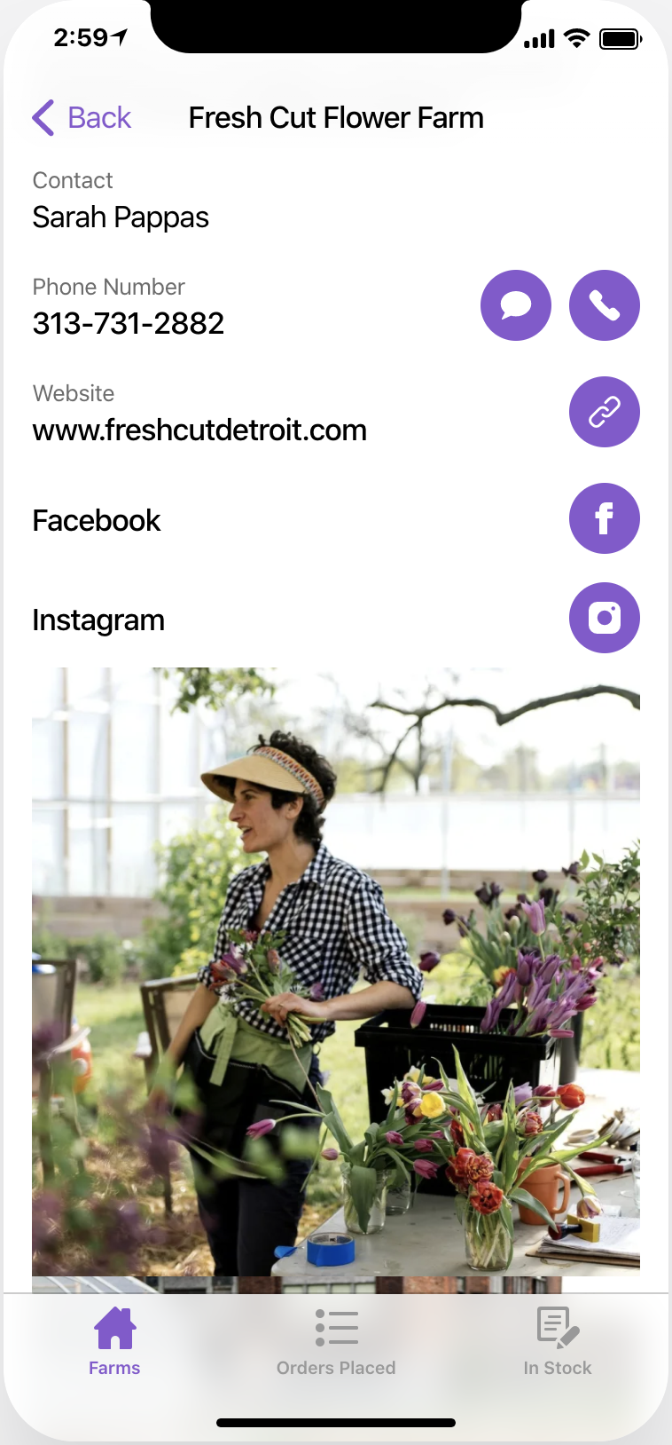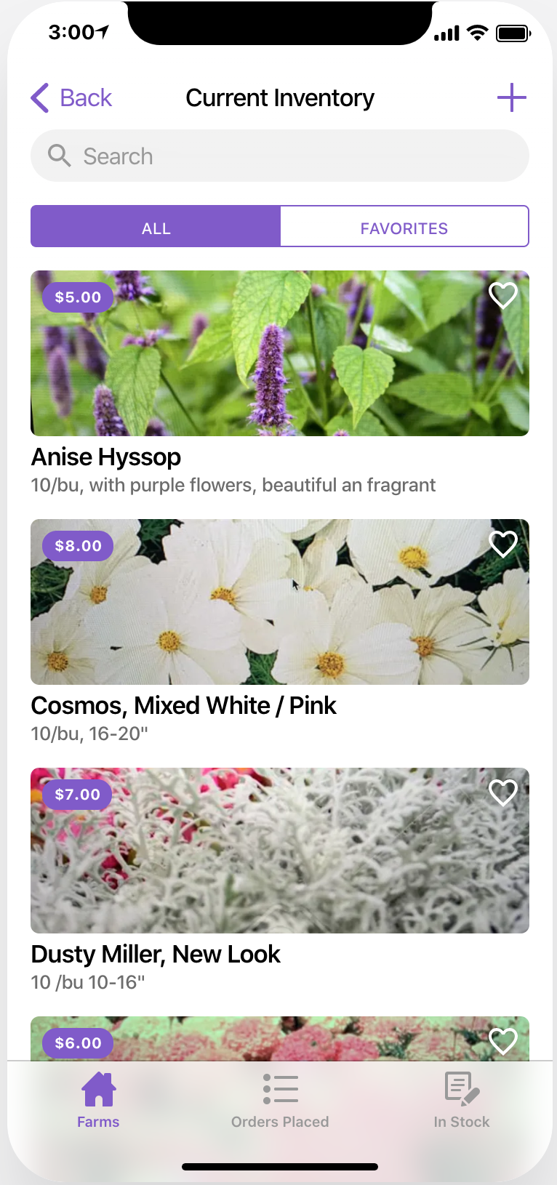

**View Demo:**

To access a demo of the webapp and see what Glide can do, scan the QR code with your camera’s phone to view an interactive demo of it.

<http://fhtwa.glideapp.io>



**Modified Spreadsheet:**

<https://docs.google.com/spreadsheets/d/1EWlEWjSLDRVLUPYPqll0RZ2BFaaiUwK_Qwwwjua0wzc/edit?usp=sharing>

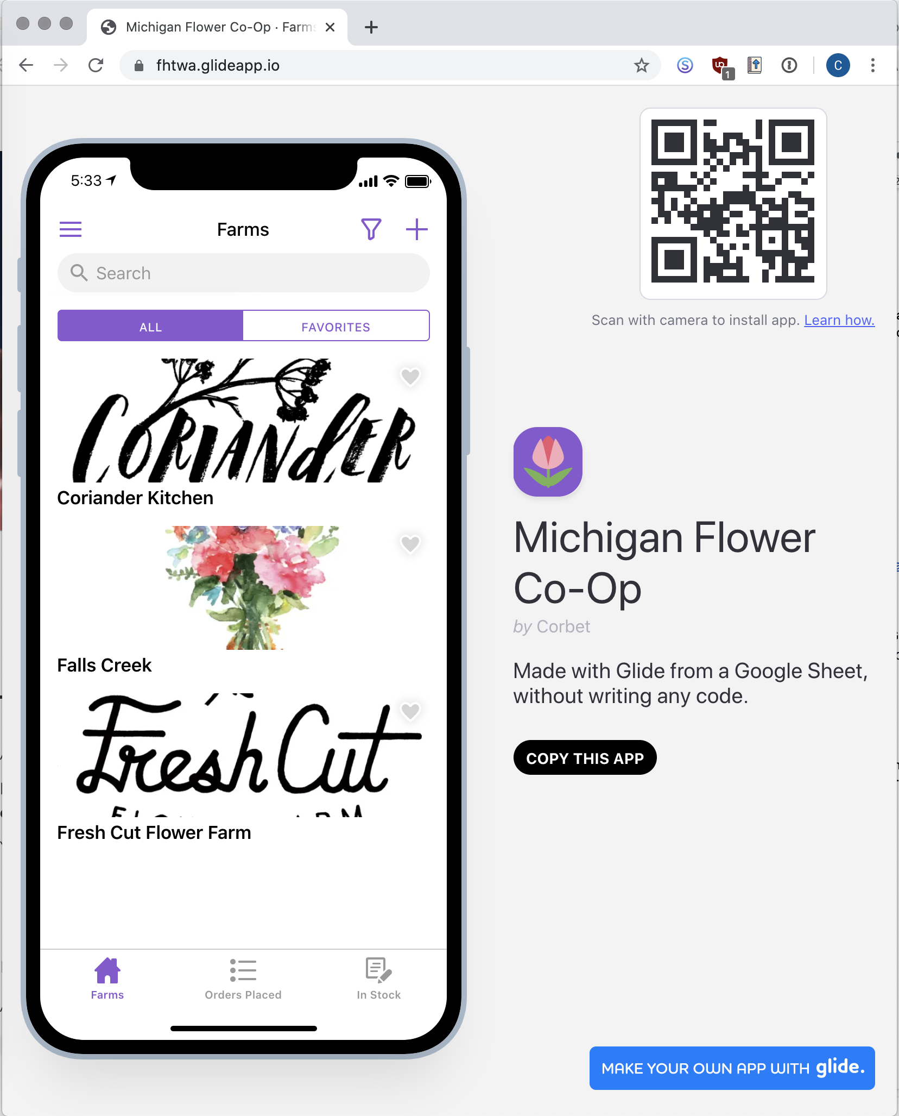

**How to Copy My Demo**

Once you are signed up for Glide’s free account, you can go to fhtwa.glideapp.io from your web browser and select “Copy This App” button, shown below. A copy of the app will then be saved on your Glide account.

**Initial Setup**

Glide will require some reformatting of the original MFGC spreadsheet, including removing any empty rows and columns. For further information, I highly recommend Glide’s extensive [youtube channel](https://youtu.be/t5UqouXcH5U).

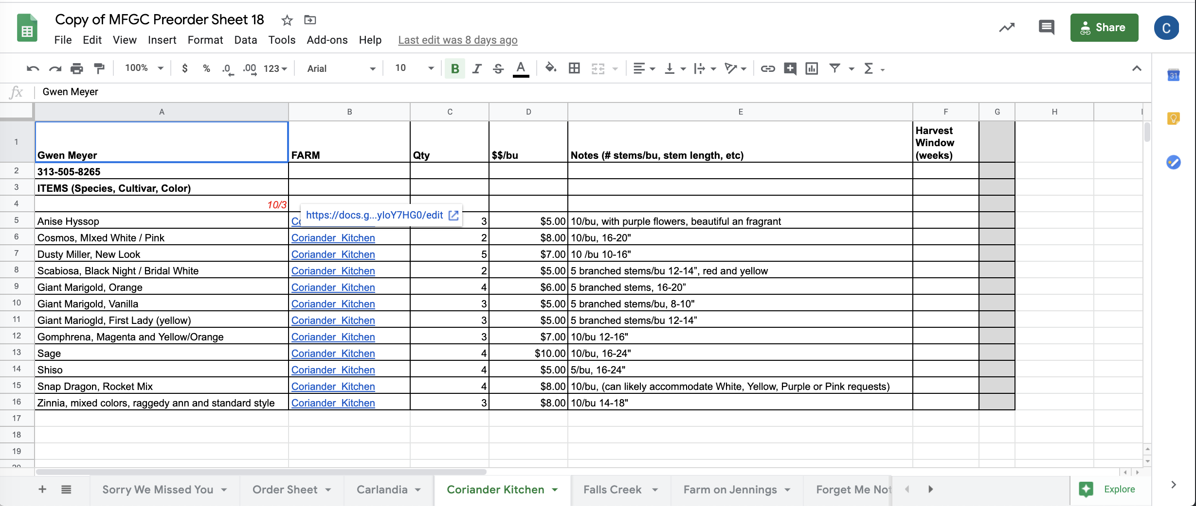

Spreadsheet Before

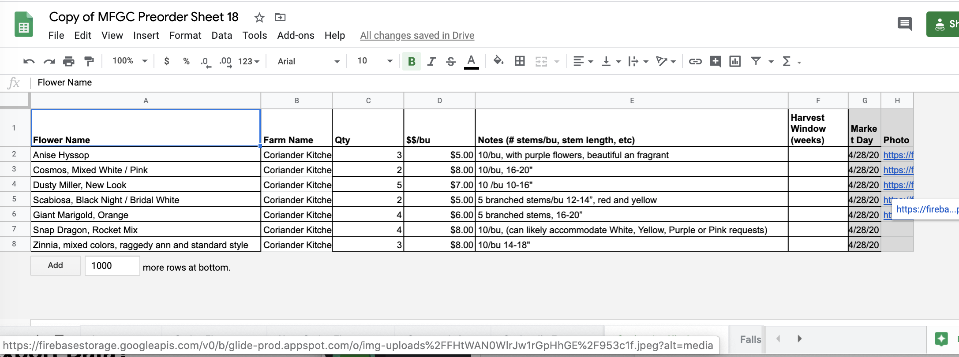

Spreadsheet After

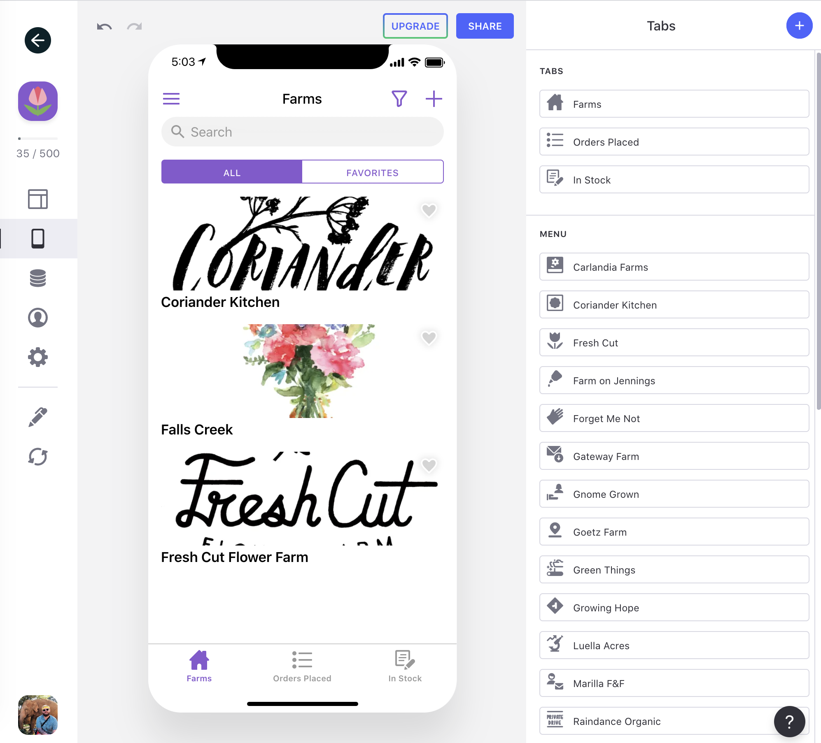

**Bottom Navigation Buttons**

When you enter Glide’s interface, you can select which sheet you want to present as a tab on the bottom part of your webapp in the “Tabs” section. For your demo app, I created a sheet that listed all of the grower’s information, and then moved that sheet to the Tabs section and named it “Farms” within Glide (see below). I was also able to customize the icon.

Tabs Section

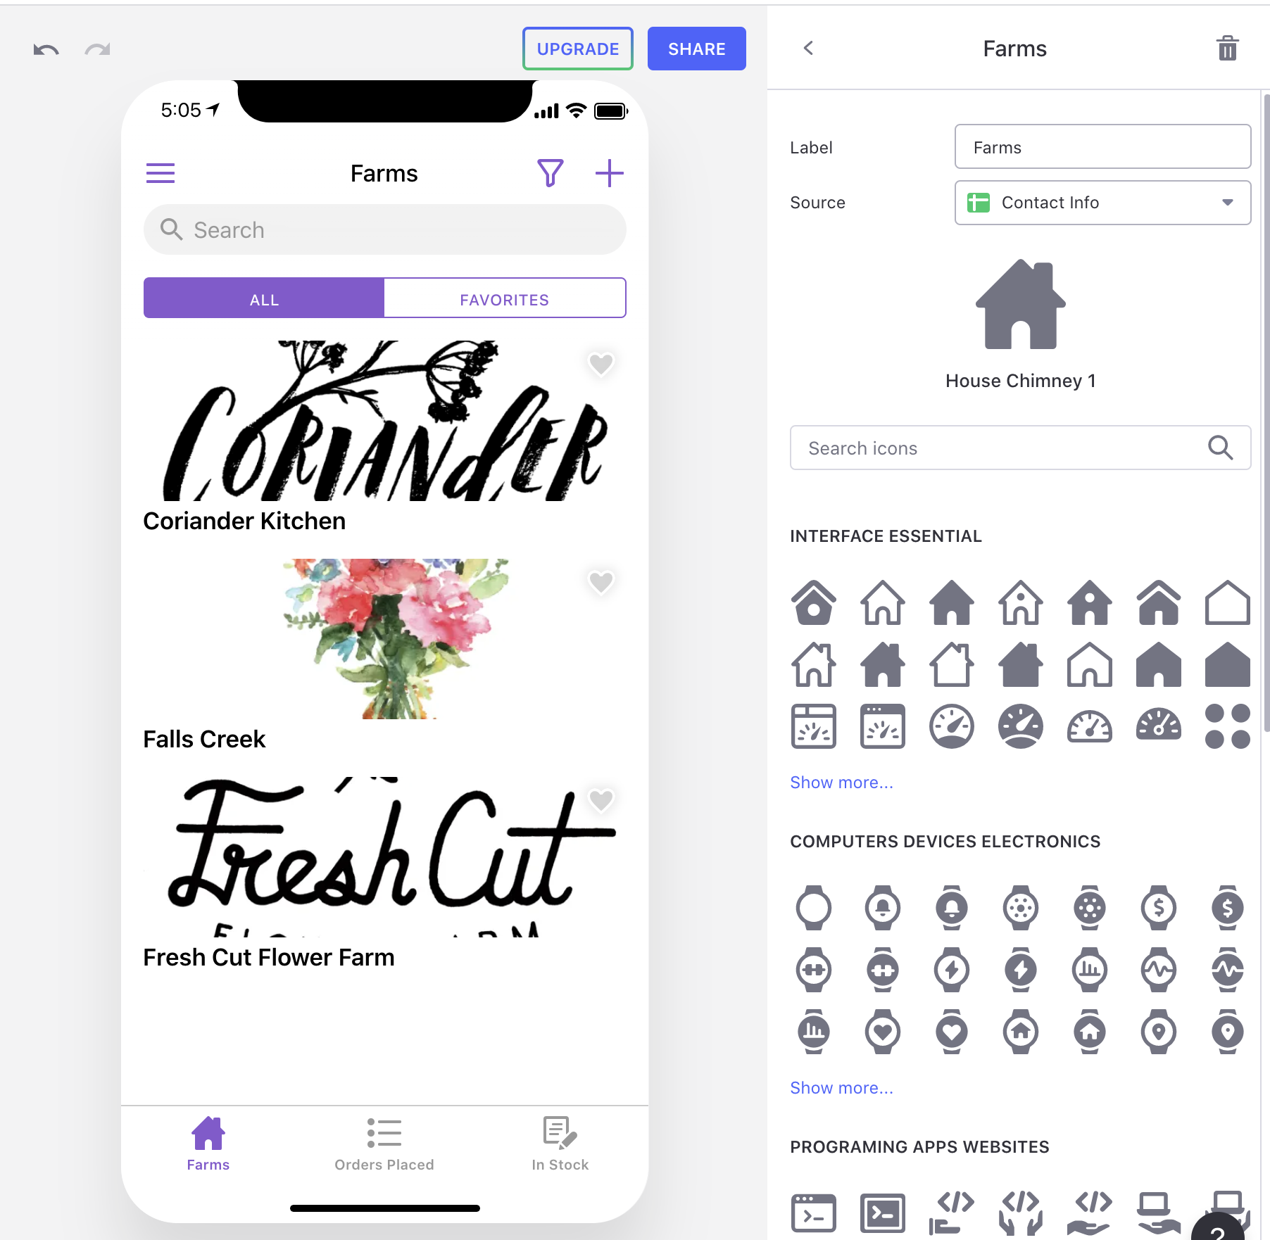

After clicking on “Farms”, I was able to change the Label and icon.

**How Spreadsheet Data is Displayed**

Within Glide, a spreadsheet’s row will become lists of items within Glide. When you tap on a list item, Glide will show a details screen summarizing the row from the spreadsheet. To customize this information you need to access the “Layout” section within Glide, where you can customize how the data is presented. You can even choose to create filters and sorting, so only certain information is displayed - in the screenshots below for the “Orders Placed” tab, you’ll notice I set data to only be shown if the market day is in the future.

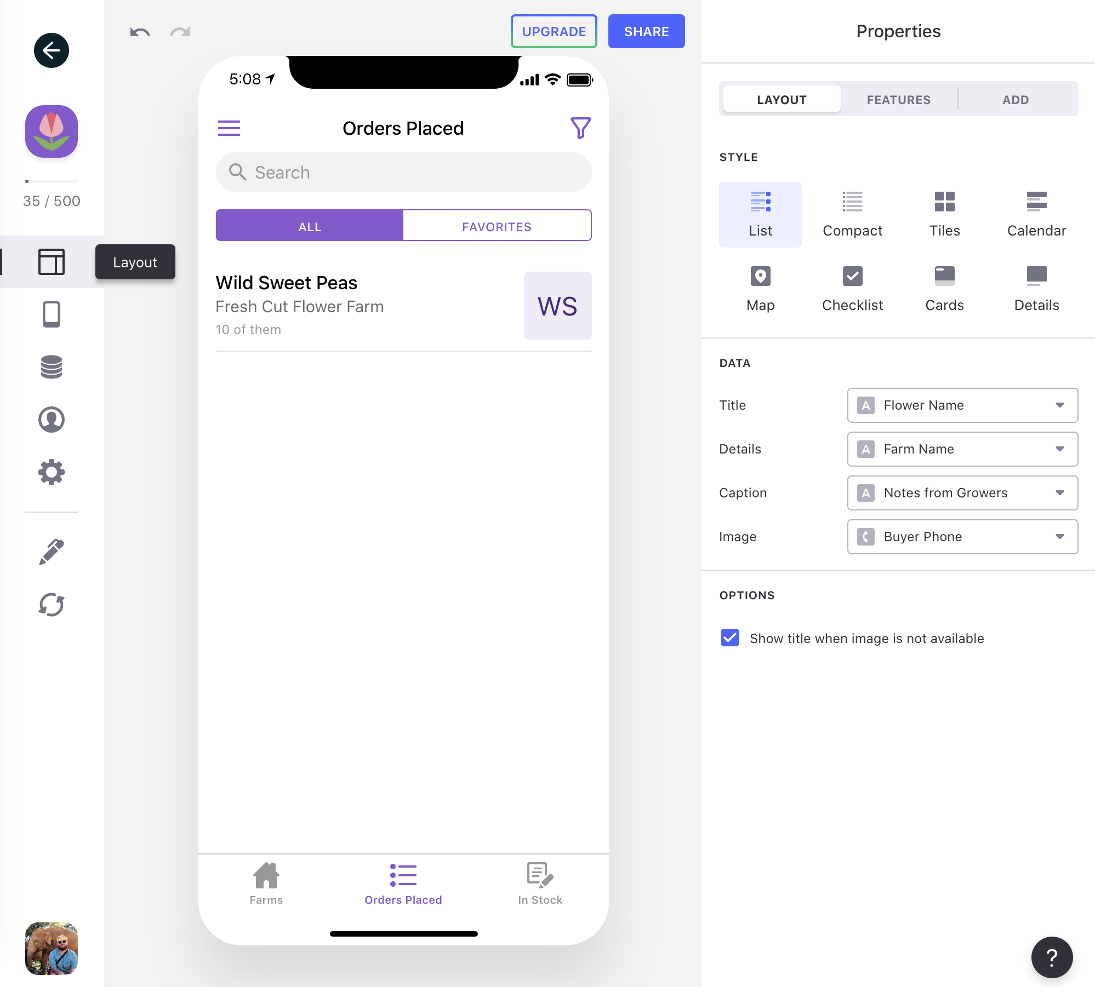

Layout > Orders Placed > Layout, where you can decide how you want sheets to look within your Glide webapp.

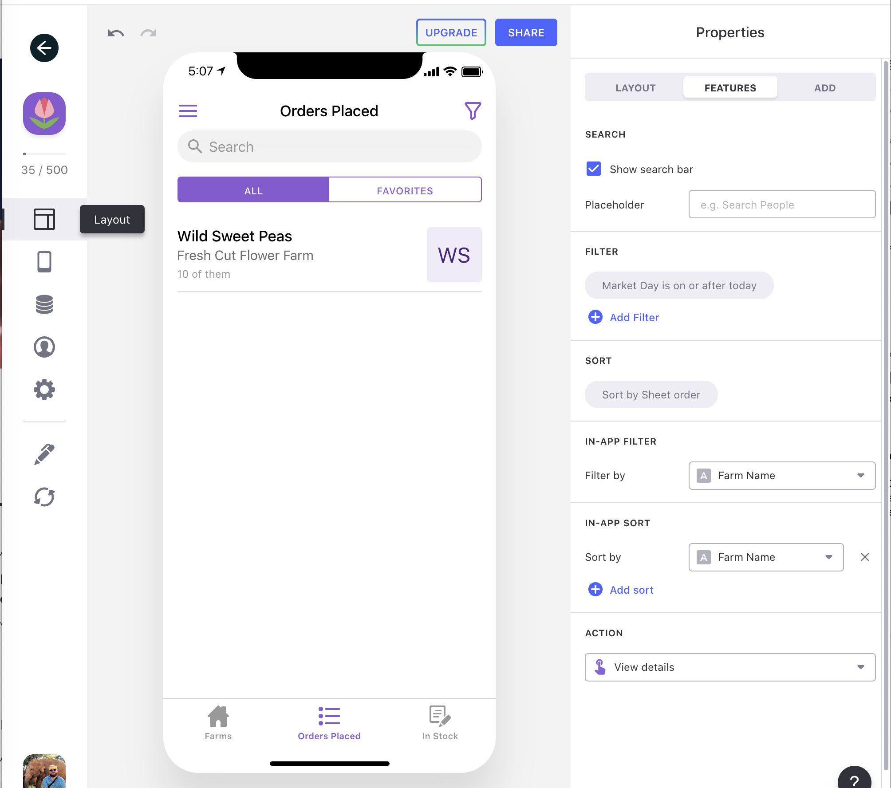

Layouts > Orders Placed > Features, where you can adjust things like sorting and filtering

**Making Information Editable**

If you were to click on the “Wild Sweet Peas” data from the spreadsheet above, you’ll be greeted with information from the row of data. This information can be further customized and displayed in any way you see fit.

After clicking on “Wild Sweet Peas”, you are able to modify the layout and settings for data within that specific sheet as Components. Individual Components can be customized, and you can even Edit Components to act on your data from the spreadsheet in different ways. Maybe you want a row containing phone numbers to have a button that lets mobile users text or click them with a click of a button.[This is one of Glide’s most powerful and useful features, and I highly recommend clicking here to learn more.](https://docs.glideapps.com/all/guides/quick-starts/getting-started/what-are-components)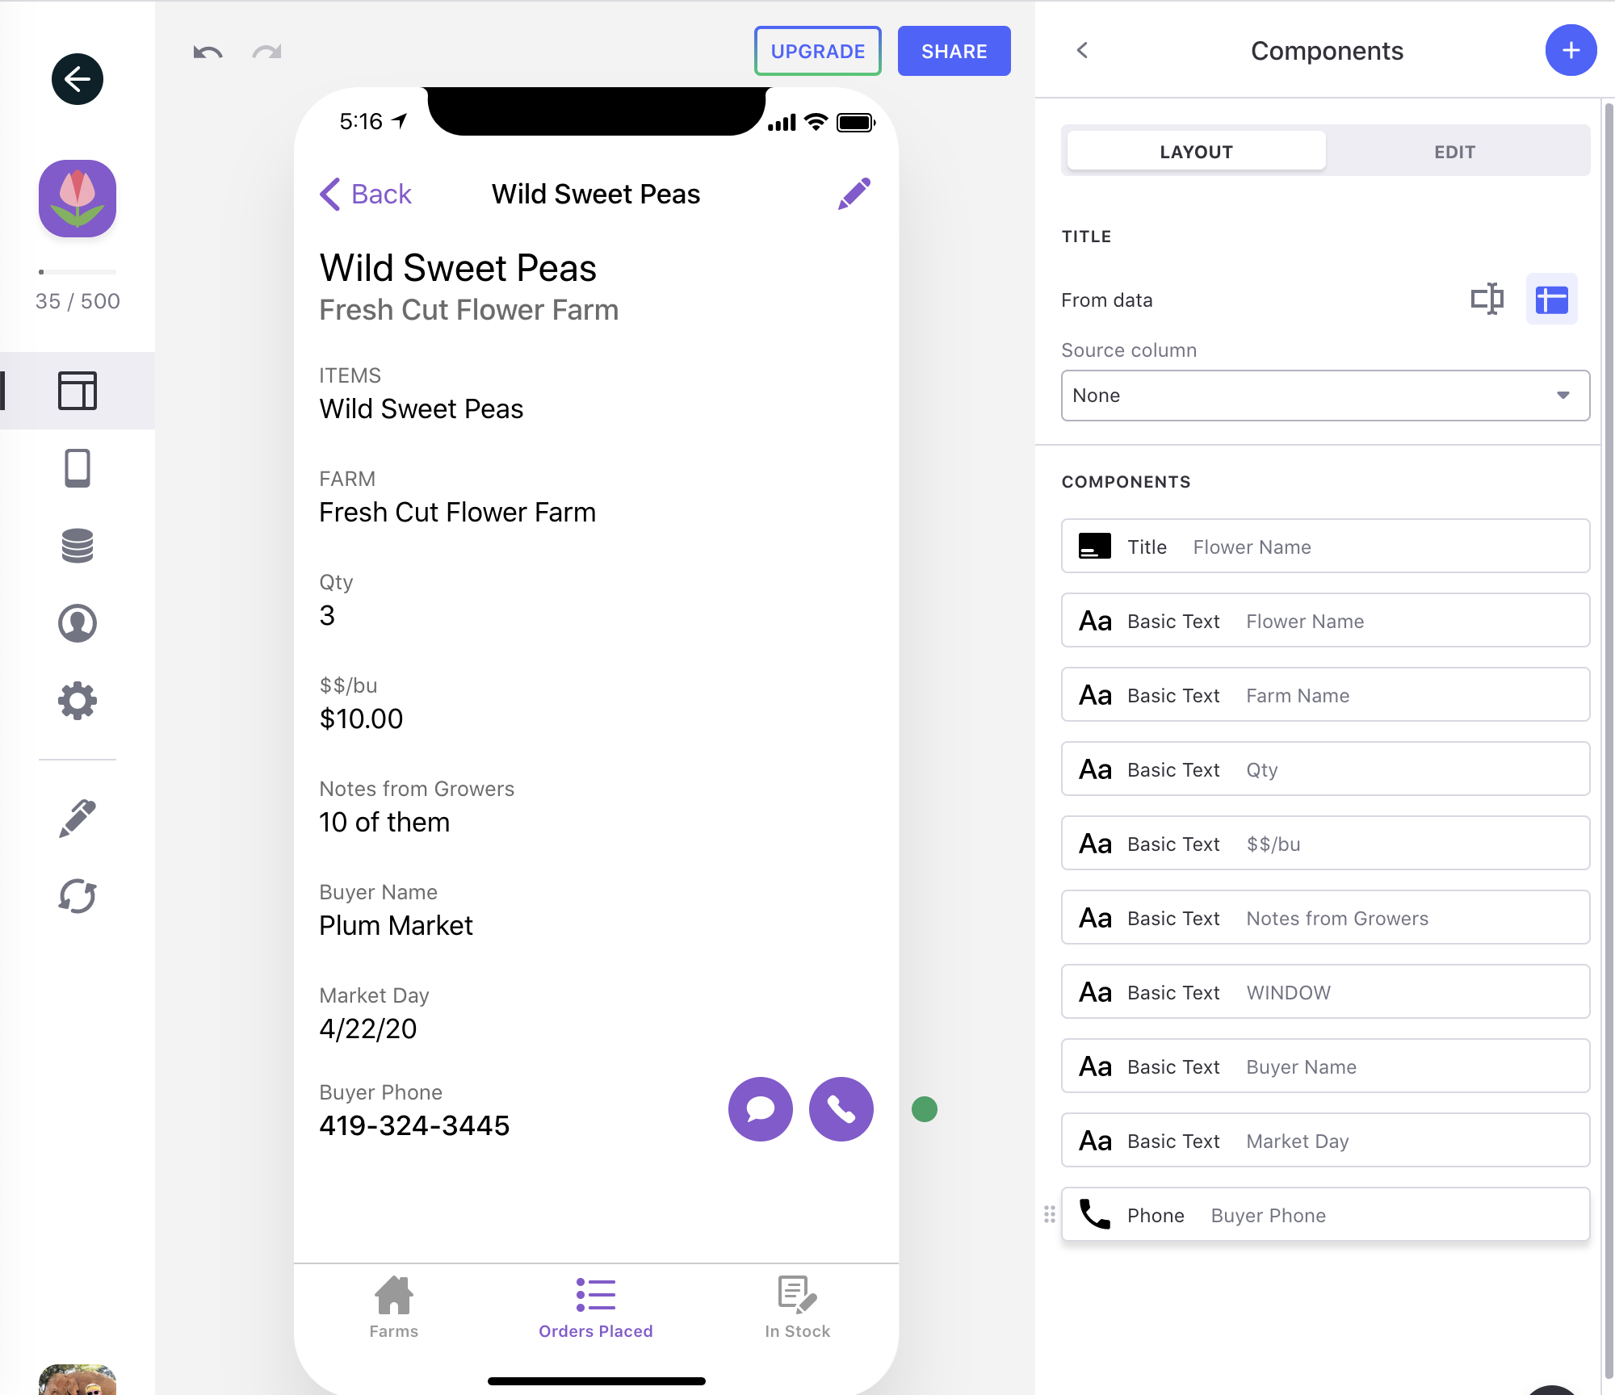

Layout modifier for the “Orders Placed” sheet

Under Layout > Edit, you can choose to allow users to edit data within that specific sheet. You can even setup member rights so only certain specific users can add, modify, or delete information (see below).

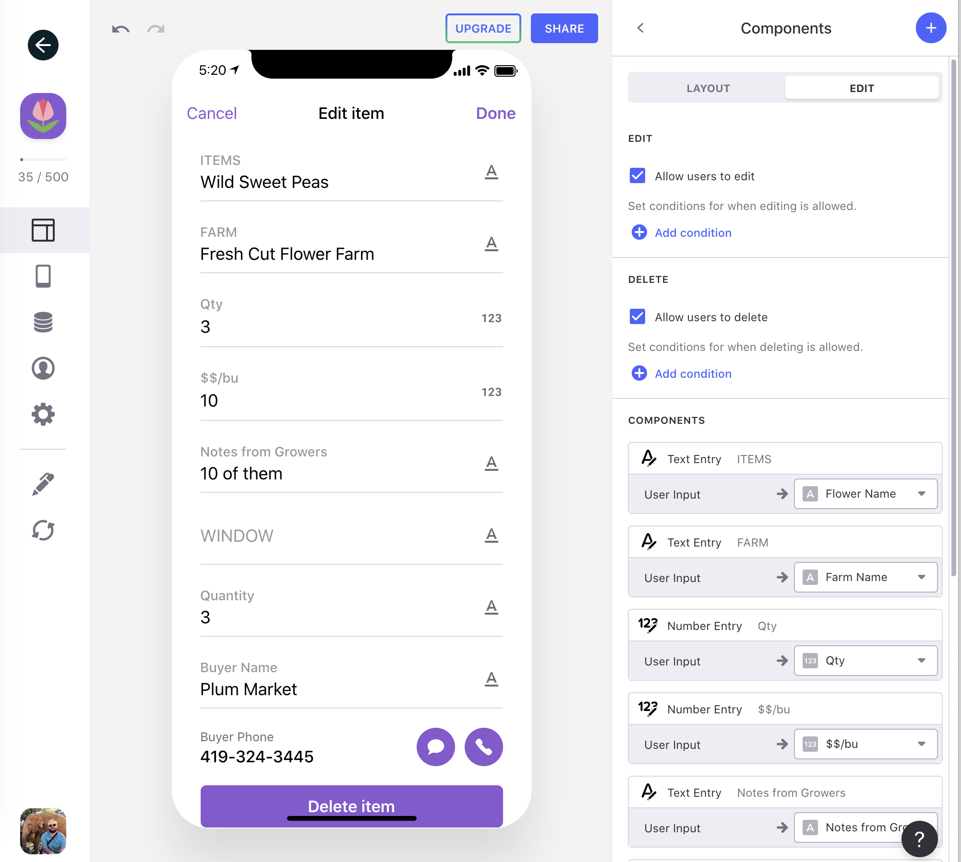

Layout > Edit, where you can choose to let all or some users edit certain components.

**Login, Privacy, and Signing-in**

If you’d like to limit who can access certain information, you may want to explore requiring users to log-in to your webapp to make changes. Thankfully, users are only required to have a Google account, but you can also require a unique account to access your webapp. [Click here to learn more about user accounts.](https://docs.glideapps.com/all/guides/quick-starts/getting-started/controlling-who-can-access-your-app)

**Other Questions or Concerns**

If you have any questions or comments related to how to accomplish something in glide, please don’t hesitate to reach out to me at corbetgriffith@gmail.com

**Local Line**

**Website:**<https://site.localline.ca/>

**Pros:** Handles all e-commerce, currently partners with other local farmers and vendors (Argus Farms)

**Cons:** More expensive, does not integrate with Google Sheets

**Description:** Local Line is a new online system that helps food suppliers directly market and sell their products online through a web-based farmers market. Local Line lets suppliers manage their inventory in real-time using any device including smartphones, tablets, and computers. Florists looking to pre-order flowers can access an online store where they can easily sort, filter, and view inventory that is available for pick-up. Florists can choose for orders to be paid during the ordering process, or during pick-up.

Local Line offers optimized systems for three different types of users: Farmers17 looking to efficiently manage orders, customers, and inventory, Food Hubs18 looking to streamline fulfillment and make selling easier, and Food Markets19 that want to create an online market where separate vendors have the flexibility to pre-sell online.

Recently, Ann Arbor-based Argus Farm’s uses Local Line20 to coordinate pre-orders with over 200 farmers to create a wholesale food hub.21 I would highly recommend leveraging your existing relationship with Argus Farms to learn more about whether or not Local Line is a good fit for you.

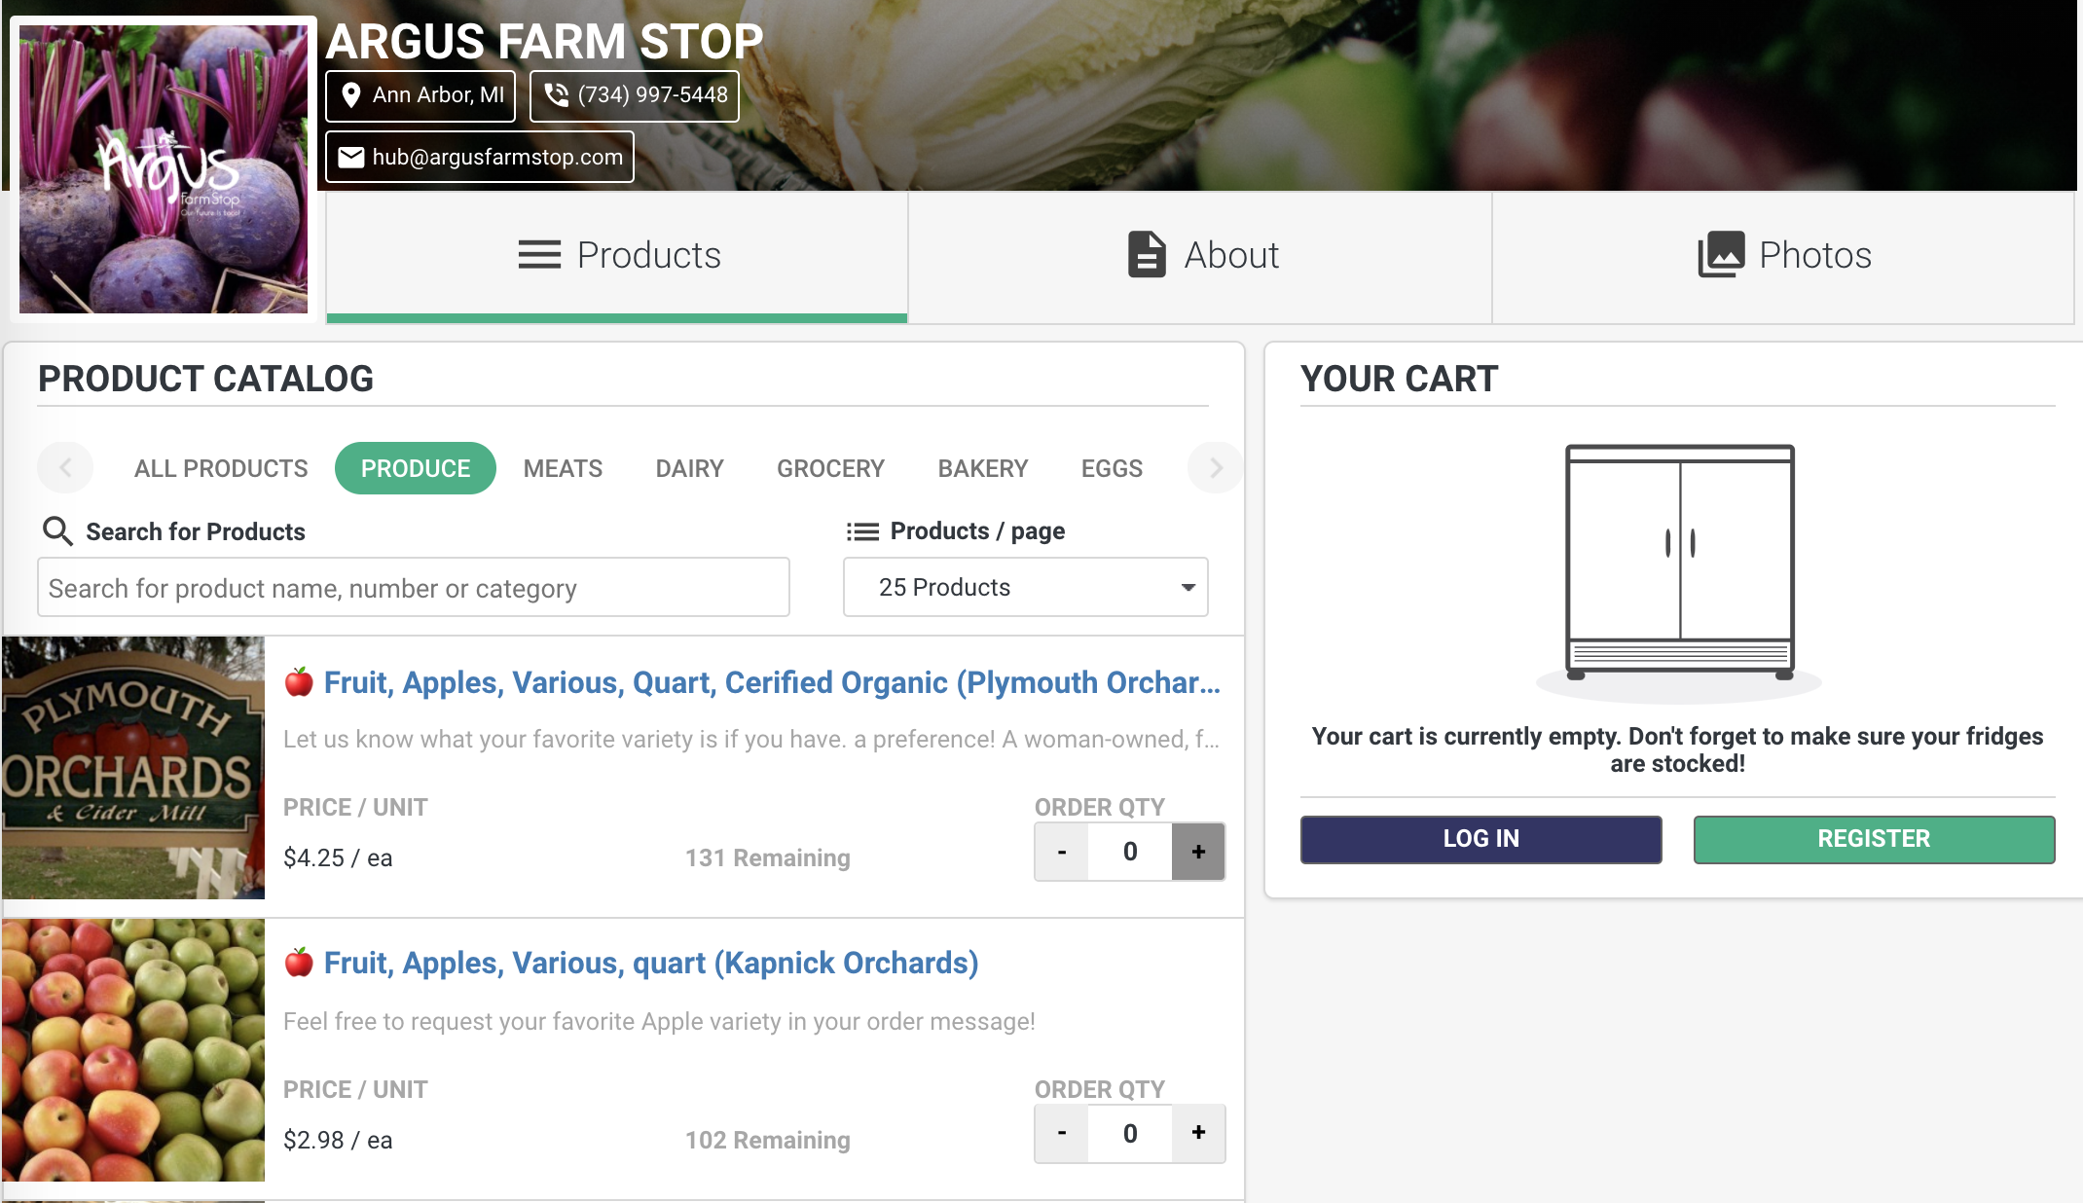

**Other Flower Wholesaler’s Solutions**

Seattle Wholesale Growers Market

**Website:**<http://seattlewholesalegrowersmarket.com/>

**Pros:** Visually stunning images of flowers

**Cons:** Google Sheets back-end (protected), not mobile friendly

**Description:** During the initial client meeting, the **Seattle Wholesale Growers Market**  was mentioned as a potential source of inspiration. Known for being one of the biggest member-owned flower markets in the world, the Seattle Growers Market brings together dozens of growers to provide direct sales to both florists and consumers in the Seattle area.

Currently, the Seattle Wholesale Growers Market provides flower availability broken down by month13. External links send potential buyers to per-date specific **Google Sheets**, which lists actual inventory for the week’s market. 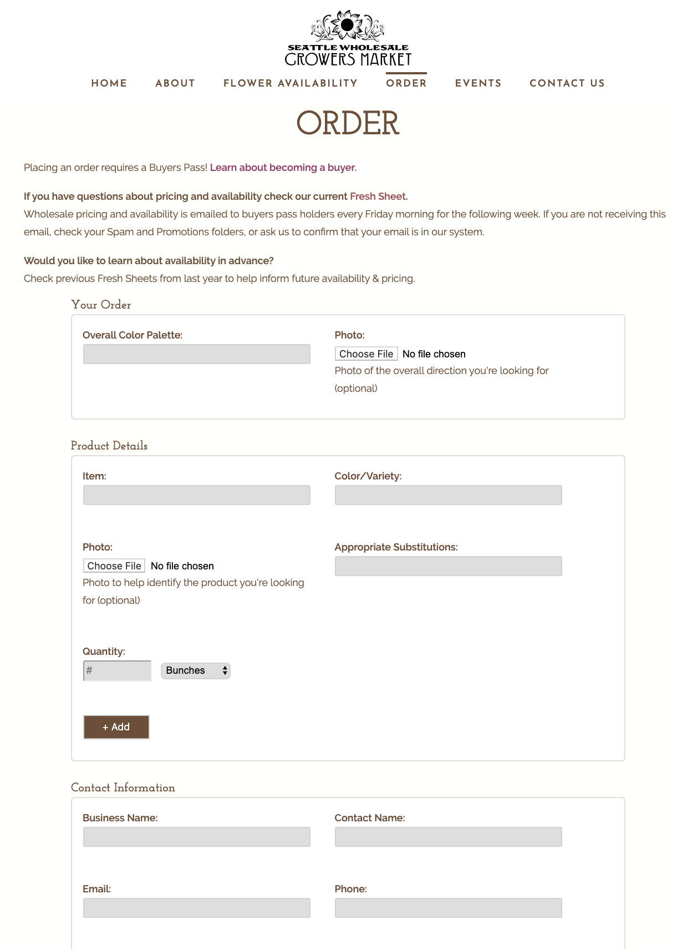



1. Seattle Wholesale Growers Markets Availability,<http://seattlewholesalegrowersmarket.com/availability/>
2. Seattle Wholesale Growers Market Order Form,<http://seattlewholesalegrowersmarket.com/order/>
3. Local Line Supplier Management, <https://site.localline.ca/food-hubs/supplier-management>
4. Local Line Farmers, <https://site.localline.ca/farmers/farmers>
5. Local Line Food Hubs, <https://site.localline.ca/food-hubs/food-hubs>
6. Local Line Food Markets, <https://site.localline.ca/markets/markets>
7. How Argus Farms Uses Local Line, <https://blog.localline.ca/how-argus-farm-stop-uses-a-retail-store-food-hub-and-local-line>

1. <https://docs.glideapps.com/all/guides/quick-starts/getting-started/background-refresh>
2. https://zapier.com/home